Software Development Unit 3, 3.4

Anna Legaspi

# I can setup and use access rights to enable others to access information

In the previous homework, Unit 3, 3.3, I demonstrated setting up access for my tutor in Google Drive. In this unit, I will demonstrate how to provide access to a list of people and also how to control the access I’m granting.

Similar to the previous unit, I’ve located the exact folder that I wanted to share with people. I then checked the right hand side where I can ‘Manage access’.

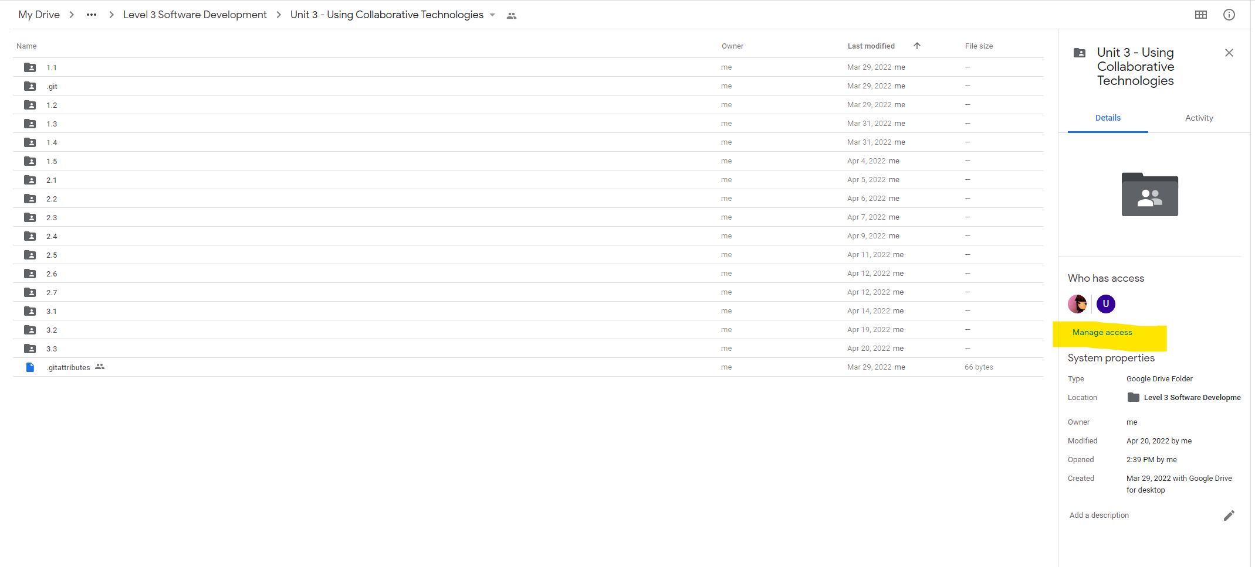

Upon selecting ‘Manage access’, I’m prompted with a list of people that already have access to the folder and the ability to add more people and groups if I wanted to. The type of access granted is also confirmed beside the person’s details.

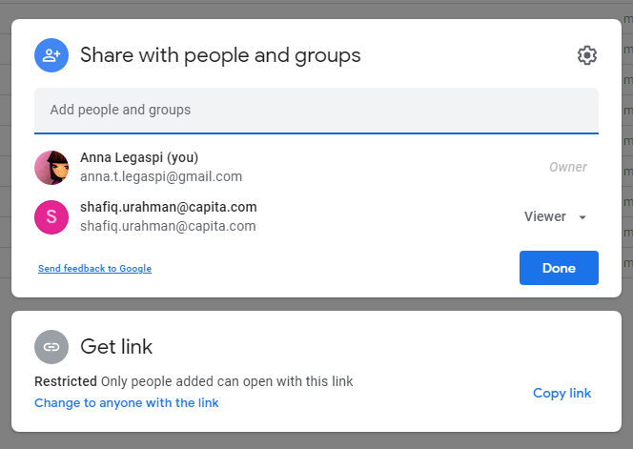

To add more people, I simply type the email addresses I want to add in the ‘Add people and groups’ field. I’ve added a random email address for this exercise. Google has then prompted me to add sharing restrictions.

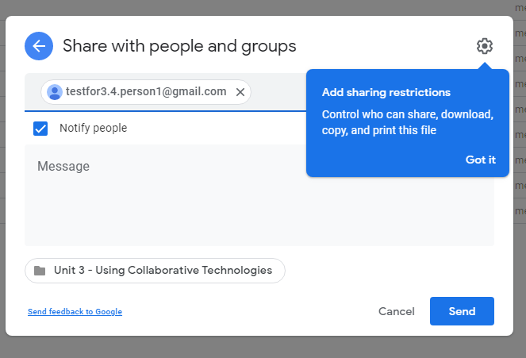

If I select the dropdown ‘Editor’, I’m presented with 3 options: Viewer, Commenter and Editor. This is where I can control how each person can access my files.

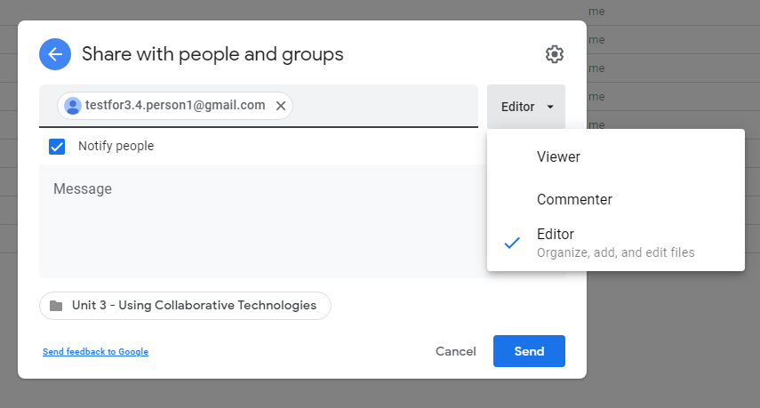

In the previous homework, I’ve made my tutor a Viewer, In this example, I will grant my test person Commenter access.

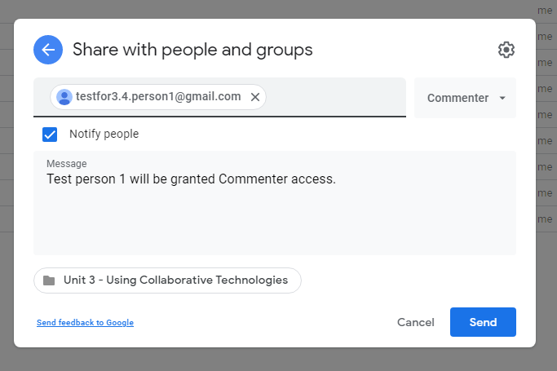

I click ‘Send’.

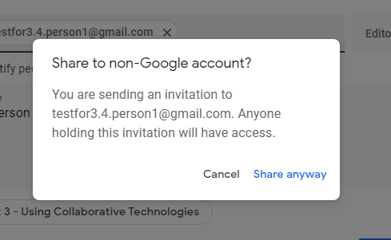

I select ‘Share anyway’ for the purposes of this example.

When I go back to the ‘Manage access’ section, I can now see my test person added to the list of people who can see my files. I can also amend their access at any point by selecting the ‘dropdown’ and choosing the appropriate access.

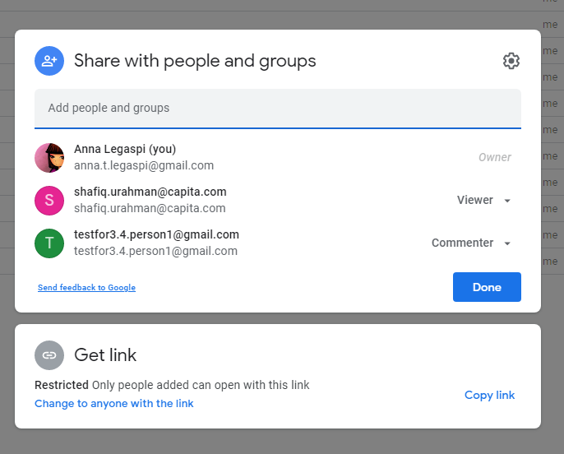

This step can be repeated as many times as needed until I have all the relevant people added to my list. Since my test person 1 is a fictional character, I am going to revoke the access I’ve just given. I can do this by selecting the dropdown and choosing ‘Remove’, then ‘Save’

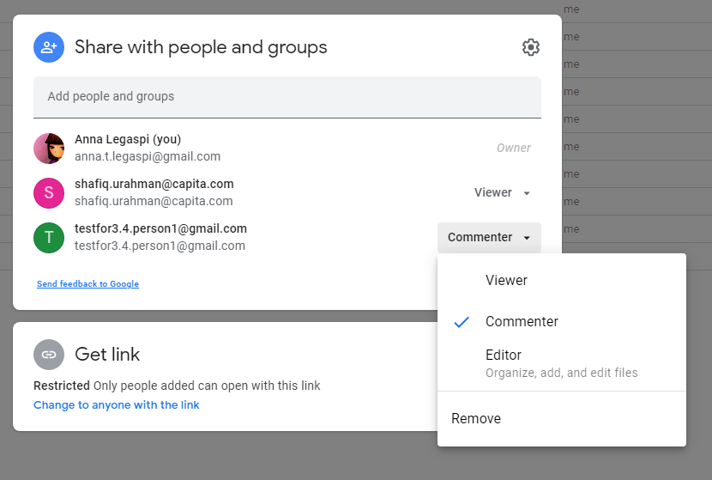

I am now back to the original list of just myself and my tutor.

